Internal Correspondence – on Meeting Agenda 1st March
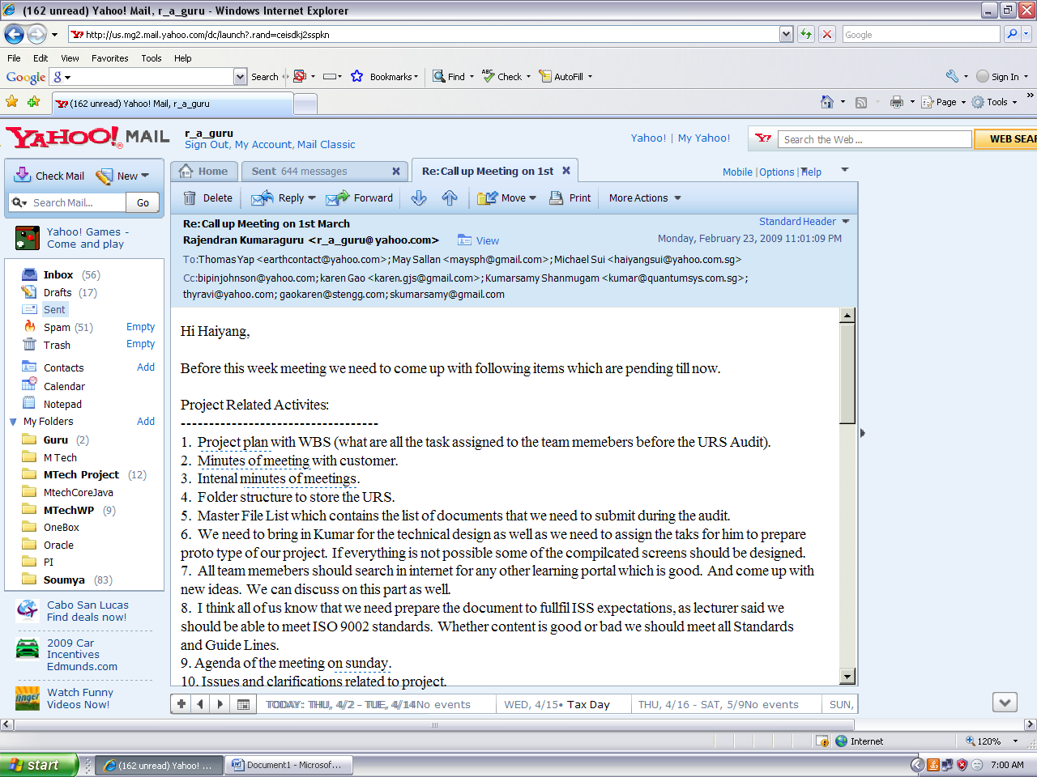

Internal Correspondence
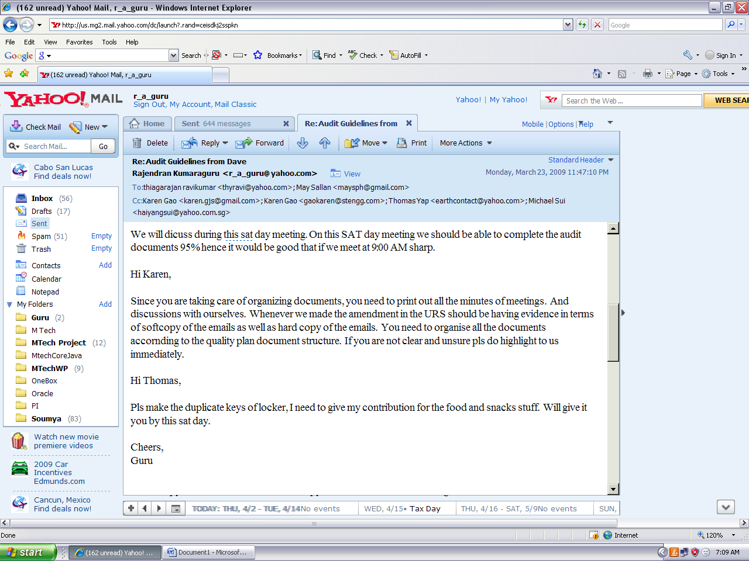

Enquiry on Kumar’s status 21-Feb-09
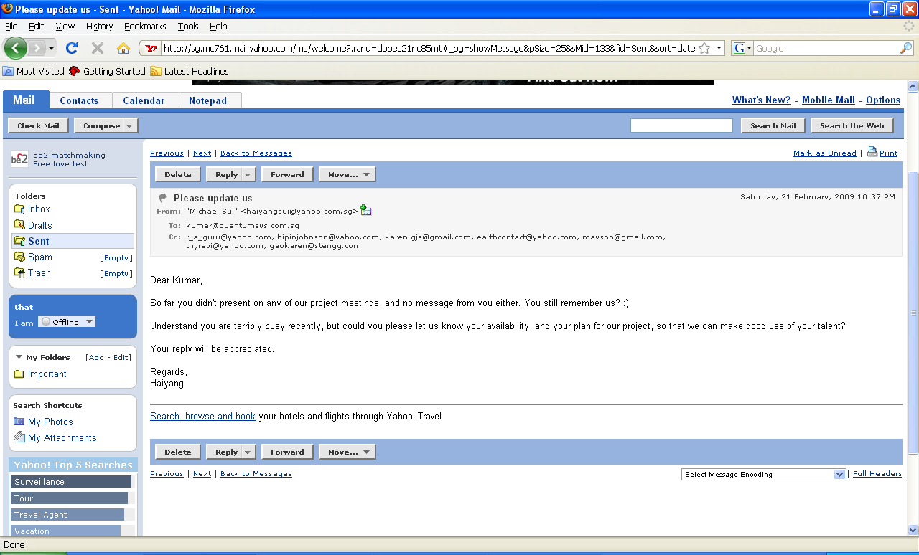

Inquiry Bipin’s status 14-March-2009

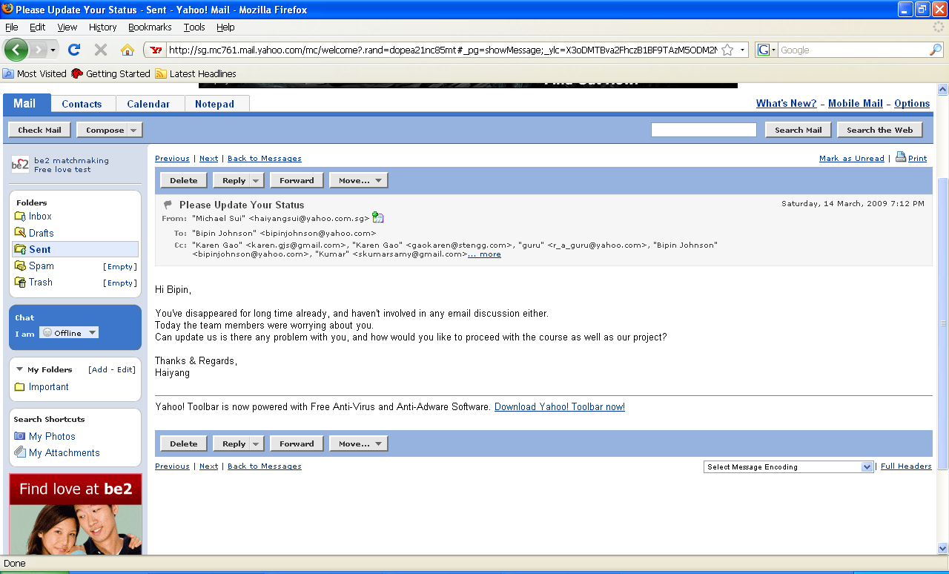

Bipin left the team 15-Mar-09

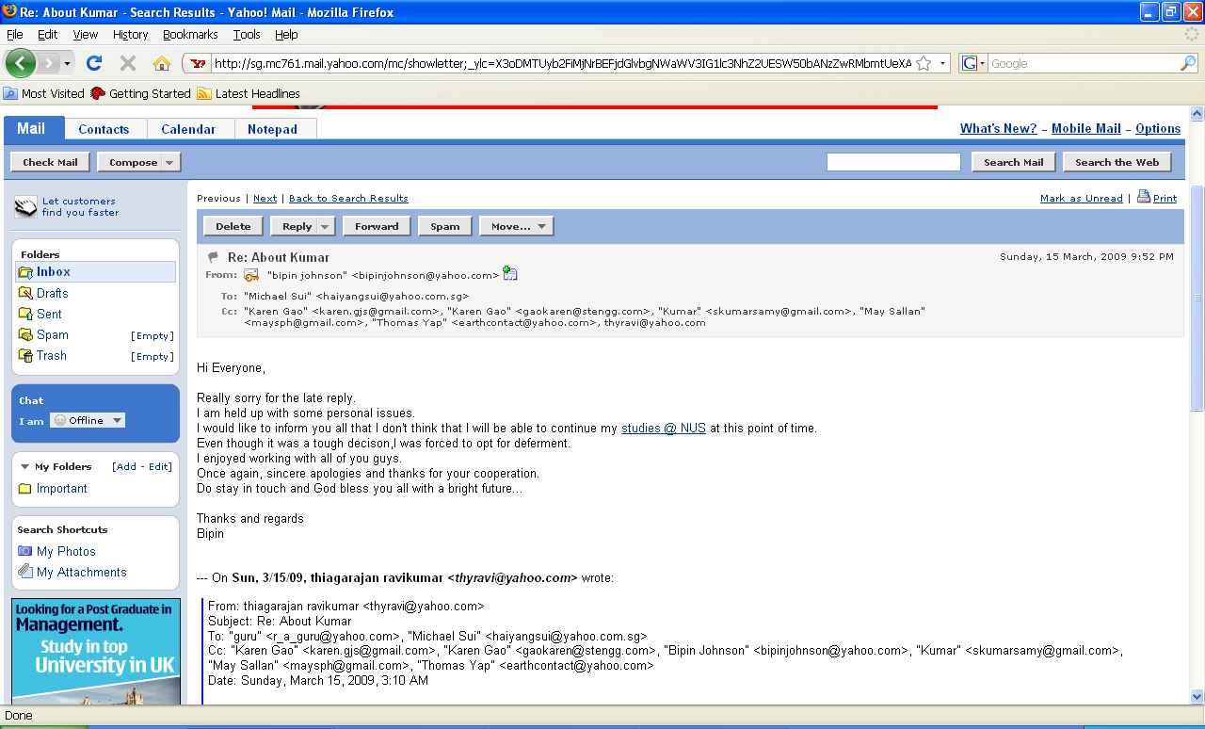

Kumar left the team 23-Mar-09

